

A

PROJECT DESIGN REPORT ON

**“UNIVERSITY RESULT LEDGER SHEET ANALYSIS”**

SUBMITTED TO THE UNIVERSITY PUNYASHLOK AHIYADEVI HOLKAR SOLAPUR UNIVERSITY, IN THE PARTIAL FULFILLMENT OF THE REQUIREMENTS FOR THE AWARD OF THE DEGREE OF

BACHELOR OF ENGINEERING IN

COMPUTER SCIENCE AND ENGINEERING SUBMITTED BY

#### Mr. Nageshkumar R Mhetre Roll no. 44

**Mr. Sandeep J Posham Roll no.45**

**Mr. Vitthal S Narayankar Roll no.46**

**Mr. Sadguru N Katakdhond Roll no.47**

UNDER THE GUIDANCE OF

#### Prof. G.T. Gurme



**DEPARTMENT OF COMPUTER SCIENCE AND ENGINEERING**

**N.B. NAVALE SINHGAD COLLEGE OF ENGINNERING UNIVERSITY OF SOLAPUR**

**2020-2021**



Certificate

This is to certify that the project design report entitles

**“University Result Ledger Sheet Analysis”**

is submitted by

#### Mr. Nageshkumar R Mhetre Roll no.44

**Mr. Sandeep J Posham Roll no.45**

**Mr. Vitthal S Narayankar Roll no.46**

**Mr. Sadguru N Katakdhond Roll no.47**

is a bonafide work carried out by above students under the supervision of Prof. G.T. Gurme and it is submitted towards the fulfillment of the requirement of Punyashlok Ahilyadevi Holkar Solapur University, Solapur, for the award of the degree of Bachelor of Engineering (Computer Science and Engineering) during academic year 2020-2021.

#### (Prof. G.T. Gurme) (Prof. A. A Phatak)

**Guide HOD**

**Department of CSE Department of CSE**

**(Dr. S. D. Navale) Principal,**

**N. B. Navale Sinhgad College of Engineering, Solapur**

**Place:** Solapur

#### Date:

**DECLARATION**

We hereby declare that the work embodied in this Project Dissertation Report entitled as “**Covid--19 Data Prediction and Analysis**” is carried out by us in partial fulfillment of the degree BE(Computer Science and Engineering) from N. B. Navale Sinhgad college of engineering, Solapur and we have not submitted the same to any other University/Institute for the award of any other degree.

#### Mr. Nageshkumar R Mhetre Roll no.44

**Mr. Sandeep J Posham Roll no.45**

**Mr. Vitthal S Narayankar Roll no.46**

**Mr. Sadguru N Katakdhond Roll no.47**

**ACKNOWLEDGEMENT**

We would like to thank to our guide Prof. G.T. Gurme sir for helping out in selecting the topic and contents, giving valuable suggestions in preparation of project design report and presentation.

We are grateful to Prof. A. A. Phatak, Head of CSE Department, for providing healthy environment and facilities in the department. He allowed us to raise our concern and worked to solve it by extending his co- operation time to time.

Goal makes us to do work. Vision is more important than goal which makes us to do work in the best way to make work equally the best. Thanks to Principal, Dr. S.D. Navale for his support and vision.

We also thank all the CSE department staff members for their extended support and valuable guidance.

Thank You,

**Mr. Nageshkumar R Mhetre Roll no.44**

**Mr. Sandeep J Posham Roll no.45**

**Mr. Vitthal S Narayankar Roll no.46**

**Mr. Sadguru N Katakdhond Roll no.47**

**ABSTRACT**

The traditional way used by universities or colleges to analyze the performance of students is time consuming and inconvenient. So we need a new approach to analyze student’s overall performance. To analyze the student’s data (marks) the data should be in particular format on which we can perform analysis.

The purpose of this project is to provide an easy way that can help to analyze result of each student. Generally universities declare the results in PDF format.The analysis of data in PDF file format become difficult, because it needs a manual way for analysis. Manual way is always very time consuming and sometimes need to prepare a new Excel file by manually entering data from PDF to Excel file.

For an educational institute analysis of student’s data is very important for continuous growth of students. Analysis of data becomes easier in Excel spread sheet. So this program transform the data of PDF file to Excel spread sheet, So further analysis on data will become easy.

|  |  |  |  |
| --- | --- | --- | --- |
|  | **Index** | |  |
| **INTRODUCTION** |  | | **………….01** |
| * Literature Survey * Problem Statement * Scope and Objective |  | | ……………01  ……………01  ……………02 |
|  |  | |  |
| * **METHODOLOGY** * **SYSTEM DESIGN** |  | | **………….03**  **………….04** |
| * Analysis Model   + DFD Level 0   + DFD Level 1 * UML Diagram   + Use-case Diagram   + Sequence Diagram |  | | ……………04  ……………04  ……………05  ……………06  ……………06  ……………07 |
| **REQUIREMENT SPECIFICATION** | |  | **………….08** |
| * Hardware Requirement * Software Requirement |  | | ……………08  ……………08 |
|  |  | |  |
| **TESTING STRATEGY** |  | | **………….09** |
| * Unit Testing * Integration Testing * System Testing * Validation Testing |  | | ……………09  ……………09  ……………09  ……………09 |
| **RESULT** |  | | **………….11** |
| * Input Format * Final Output |  | | ……………11  ……………13 |
| **CONCLUSION** |  | | **………….14** |
| **BIBLIOGRAPHY** |  | | **………….15** |

**INTRODUCTION**

#### Literature Survey:-

PDF is a versatile document format, but it can be difficult to read and edit it. To easily extract a table or edit text in a spreadsheet format, you can to convert PDF to editable Excel spreadsheets. There few applications or online PDF to Excel convertors, but these applications convert the whole PDF in Excel. Many of the times PDF has some irrelevant data that also get converted to Excel.

To perform analysis the data must be in appropriate format with required relevant data.

An Excel/CSV file store the data in tabular form that helps analyst to analyze data without any difficulty on other hand these things cannot be performed on PDF. Traditionally data analysis performed on data in Excel/CSV, but there is not a reliable way available to get PDF data into Excel.

#### Problem Statement:-

#### To find efficient way to provide the PDF result data in tabular format and compare the performance of

#### studentsby analyzing the data.

**Scope and Objective**

**Objective**:-

The purpose of this data prediction and analysis is to take the system of patient record, medicine and disease to such a level that there won’t be any difficulty for management or government to look after.

#### Scope:-

* This web site will help doctors to predict the ratio of positive cases and to take decision which will tweak the results.

# METHODOLOGY

* University declares the result which is in the format of ledger sheet. If staff wants to analyze the result then it'll be difficult because the result is in the pdf format.
* So in our project we are making the process of analysis easy.
* But we need data in tubular form like Excel/CSV to do analysis, so we're converting that pdf file into Excel/CSV file so the user can analyze result of each student.
* We're doing this project using python language and using ide as anaconda jupyter. Python has libraries that helps to convert data from one file format to another. We're currently using PyPDF2 and Numpy libraries for our project.
* PyPDF2 is used for reading the data from pdf file and Numpy is used for working with arrays and lists that we are using for analysis.
* At the beginning we take input file which is in the pdf format and we read all the data included in that file using PyPDF2 library.
* Then we extract the only data which we required and store it in another file, after that we convert the data in the file in tables and there we do our final step as analysis
* In that we analyze student data such as marks gained by student in each Subject, Students Percentage/SGPA, Overall Marks, etc.

# SYSTEM DESIGN

## Analysis Model

#### DFD Level 0:-

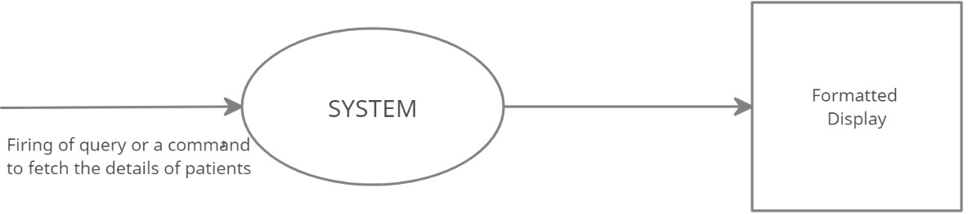

**Fig:- DFD Level 0**

**DFD Level 1:-**

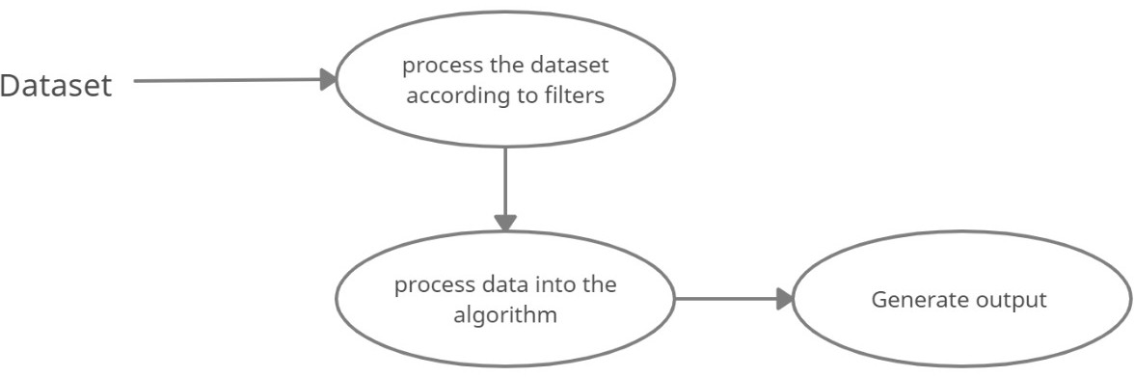

**Fig:- DFD Level 1**

**UML Diagram**

**Use case Diagram:-**

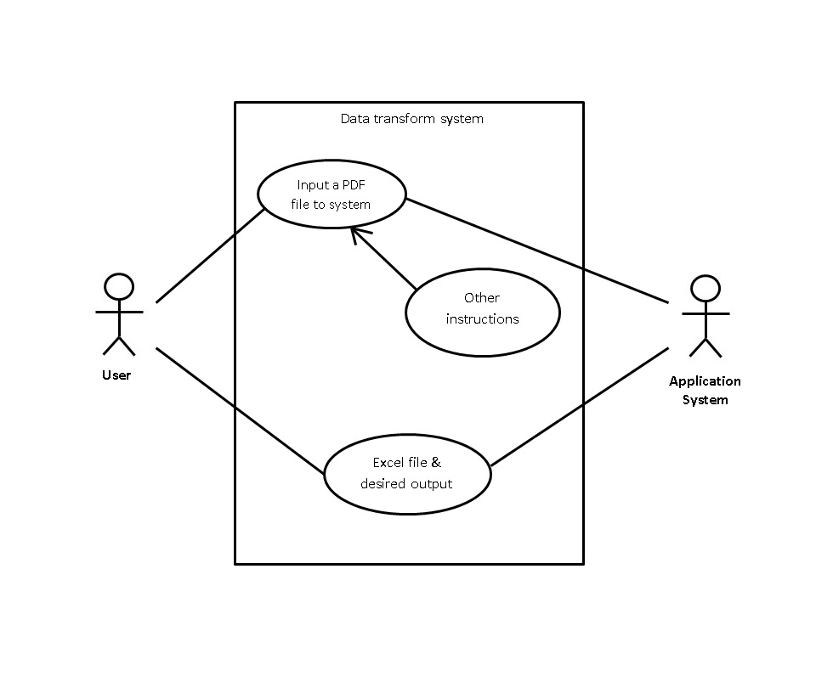

**Fig:- Use Case Diagram**

**Sequence Diagram:-**

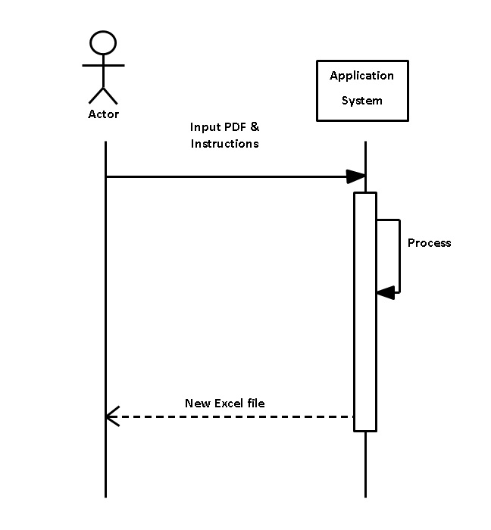

**Fig:- Sequence Diagra**

**REQUIREMENT SPECIFICATION**

 **Hardware Requirement:-**

* + **RAM**:- 1 GB or more
  + **CPU**:- PENTIUM 4 or above

 **Software Requirement:-**

* + **Operating System** :- Windows / Linux
  + **Developing Tool :-** Python 3.0, Pycharm/Anaconda
  + **Libraries** :- PyPDF2, Numpy

# TESTING STRATEGY

#### Testing

Software testing is an investigation conducted to provide stakeholders with information about the quality of the product or service under test. Software testing can also provide an

objective, independent view of the software to allow the business to appreciate and understand the risks of software implementation.Test techniques include, but are not limited to, the process of executing a program or application with the intent of finding software bugs.

Software testing can be stated as the process of validating and verifying that a computer program/application:

* + - Meets the requirements that guided its design and development,
    - Works as expected,
    - Can be implemented with the same characteristics.

#### Black Box & White Box Testing

Software testing methods are traditionally divided into white and Black box testing. These two approaches are used to describe the point of view that a test engineer takes when designing test cases.

#### Black Box Testing

Black-Box testing treats the software as a “black box”, examining functionality without any knowledge of internal implementation. The tester is only aware of what the software is supposed to do, not how it does-it.We have done testing of all the modules of our website whether all the web pages are redirecting correctly.

#### White Box Testing

White-Box testing tests internal structures or workings of a program, as opposed to the functionality exposed to the end-user. In white-Box testing an internal perspective of the system, as well as programming skills, are used to design test cases. We tested coding and internal working of website. It includes database connectivity, password encryption.

1. **Unit Testing:**

Unit testing is a software development process in which the smallest testable parts of an application, called units, are individually and independently scrutinized for proper operation. The goal of unit testing is to isolate each part of the program and show that the individual parts are correct.

### Integration Testing:

Integration testing, also known as integration and testing (I&T), is a software development Process Which program units are combined and tested as groups in multiple ways. In this context, a unit is defined as the smallest testable part of an application.

### System Testing:

Testing the behavior of the whole software/system as defined in software requirements specification (SRS) is known as system testing, its main focus is to verify that the customer requirements are fulfilled.

By combining all the modules, we satisfied the user requirements by displaying reports as per user requirements.

### Validation Testing:

Validation testing is testing where tester performed functional and non-functional testing.

Here functional testing includes [Unit Testing](https://www.javatpoint.com/unit-testing) (UT), [Integration Testing](https://www.javatpoint.com/integration-testing) (IT) and System Testing (ST), and non-functional testing includes User acceptance testing (UAT).

Validation testing is also known as dynamic testing, where we are ensuring that "we have developed the product right." And it also checks that the software meets the business needs of the client.

**Input:-**

**RESULT**

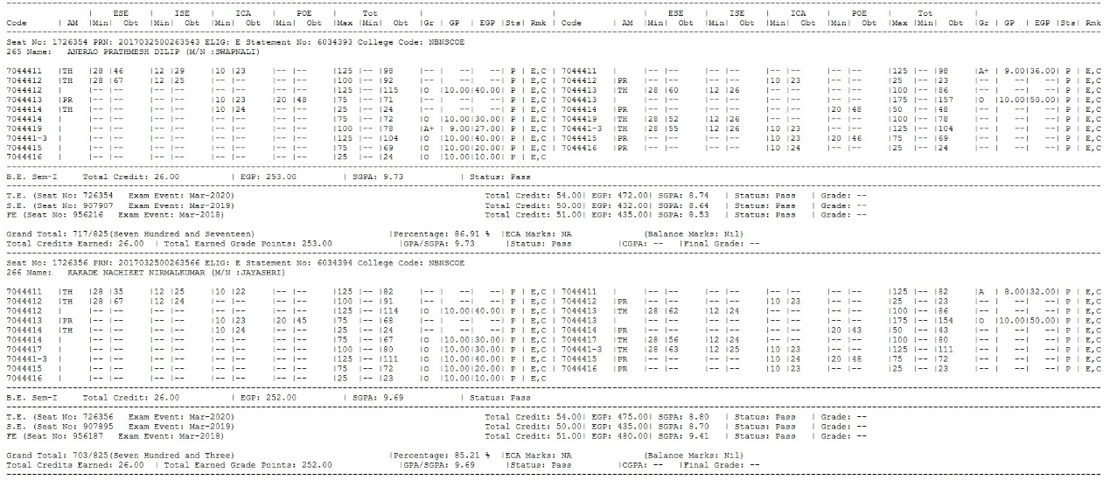

#### Fig :- Input PDF Format

**Output:-**

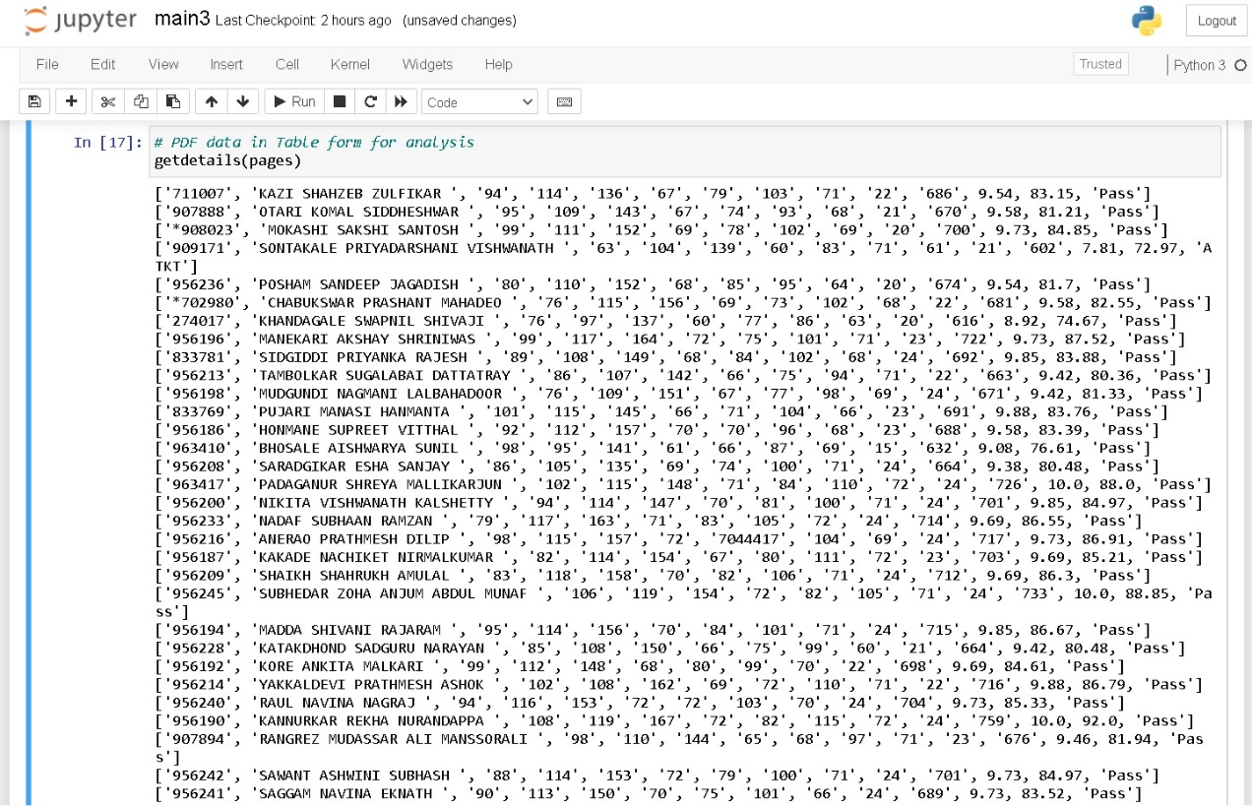

**Fig: Output of program**

**Final Output:-**

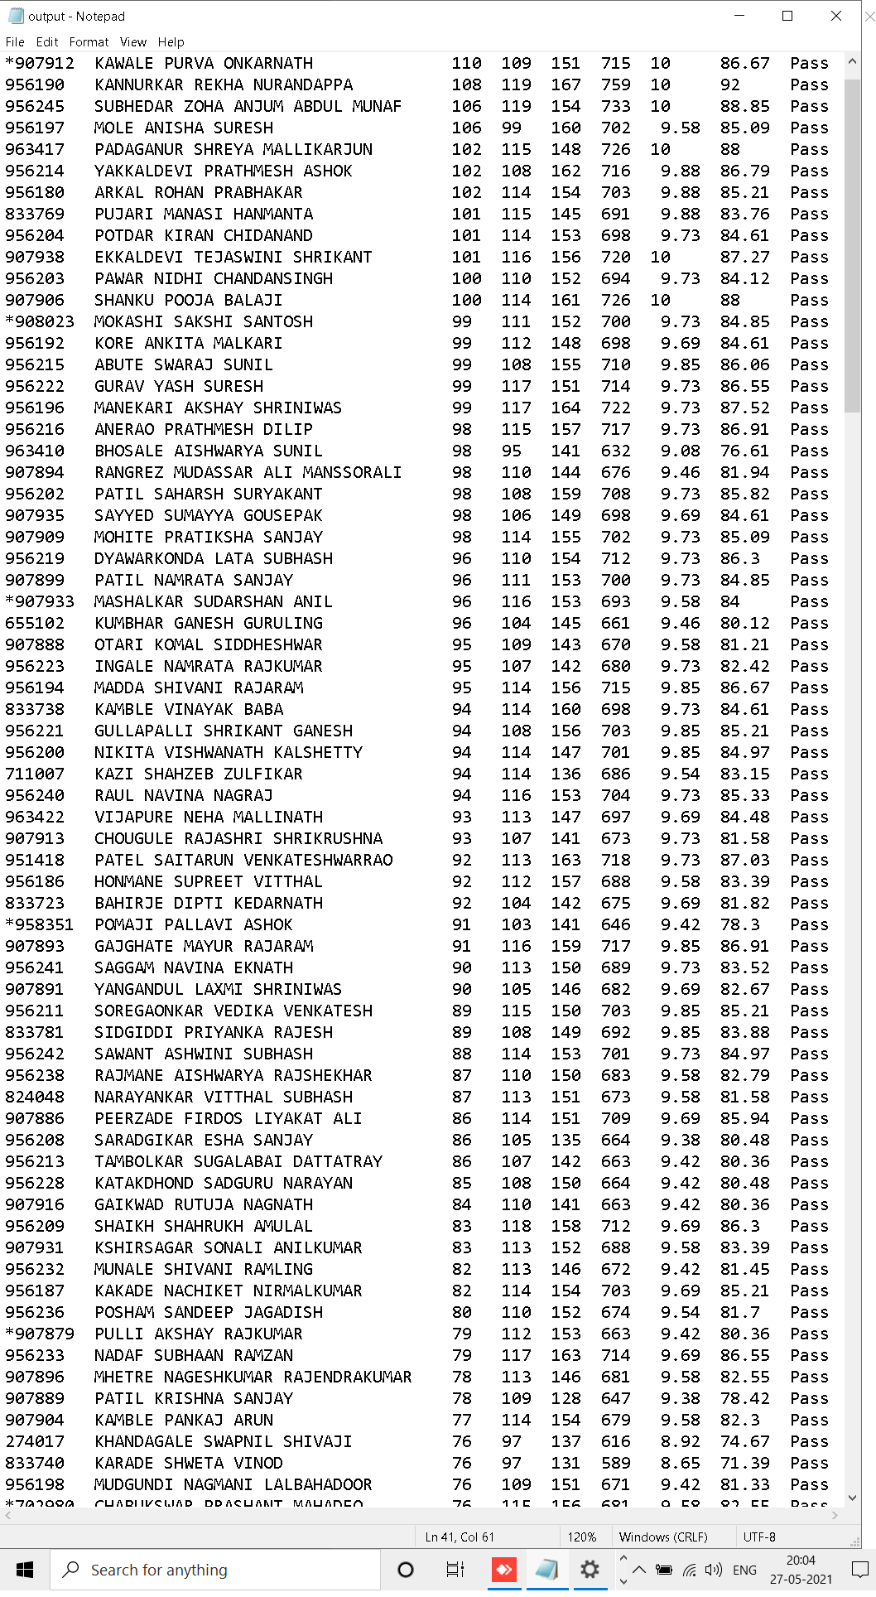

**CONCLUSION**

In this project the final output provides the data based on analysis of students data available in PDF ledger sheet.

# BIBLIOGRAPHY

#### Websites Visited:-

* <https://pypi.org>
* <https://en.wikipedia.org/wiki/Data_transformation>
* <https://www.anaconda.com>